Implementing page object model:

I have given sample files to work with this. We have four web pages and they are popage1.html, popage2.html, popage3.html and popage4.html. Each page contains links to others. Open popage1.html.

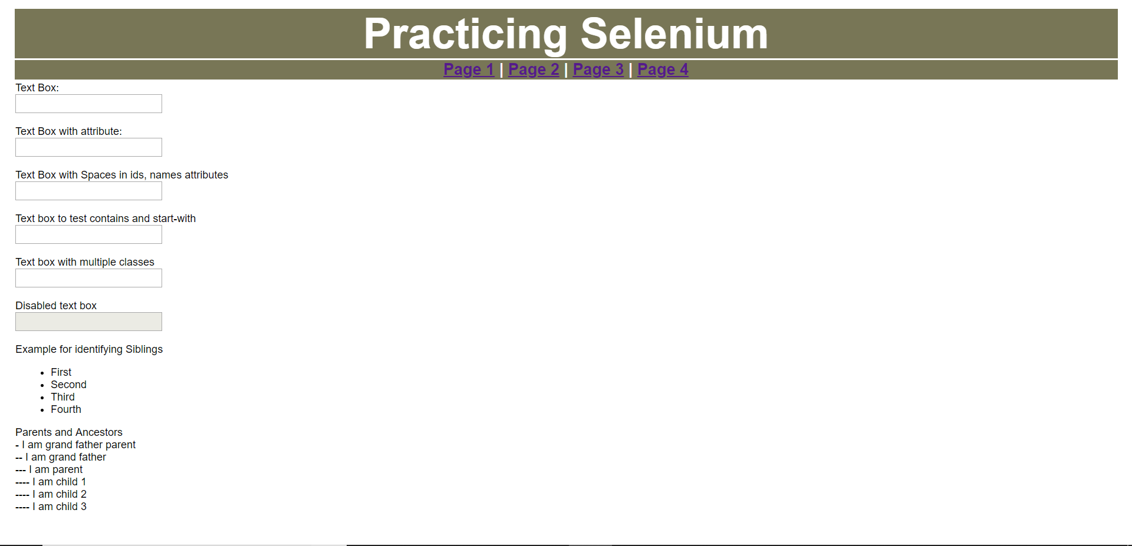

Create a new project “PageObjectModel” and create two packages “objectrepository” and “testcases” under this. “objectrepository” contains all the classes of objects (for all the four pages we have) and the test cases contain the actual test cases.

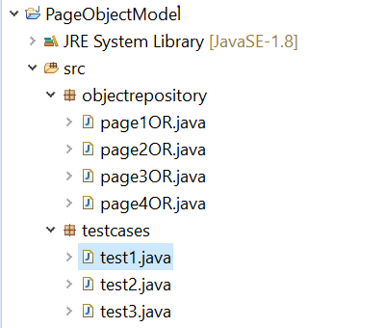

pag1OR.java:

**package** objectrepository;

**import** org.openqa.selenium.By;

**import** org.openqa.selenium.WebDriver;

**import** org.openqa.selenium.WebElement;

**public** **class** page1OR {

WebDriver driver;

**public** page1OR(WebDriver driver){

**this**.driver = driver;

}

**public** WebElement firstname() {

WebElement firstname = driver.findElement(By.*id*("firstname"));

**return** firstname;

}

**public** WebElement fnwithattr() {

WebElement fnwithattr = driver.findElement(By.*xpath*("//input[@color='red']"));

**return** fnwithattr;

}

**public** WebElement fnwithspaces() {

WebElement fnwithspaces = driver.findElement(By.*id*("first name"));

**return** fnwithspaces;

}

**public** WebElement fnstartwith() {

WebElement fnstartwith = driver.findElement(By.*xpath*("//input[starts-with(@id,'last')]"));

**return** fnstartwith;

}

**public** WebElement fnwithmultclass() {

WebElement fnwithmultclass = driver.findElement(By.*cssSelector*(".text.primary-text"));

**return** fnwithmultclass;

}

**public** WebElement page4() {

WebElement page4 = driver.findElement(By.*linkText*("Page 4"));

**return** page4;

}

}

test1.java:

**package** testcases;

**import** org.openqa.selenium.WebDriver;

**import** org.openqa.selenium.firefox.FirefoxDriver;

**import** objectrepository.page1OR;

**public** **class** test1 {

**public** **static** **void** main(String[] args) **throws** InterruptedException {

System.*setProperty*("webdriver.gecko.driver", "C:\\BrowserDrivers\\geckodriver.exe");

WebDriver driver = **new** FirefoxDriver();

driver.get("file:///D:/Selenium%20Course/Java/pageobjectmodel/popage1.html");

page1OR p1 = **new** page1OR(driver);

p1.firstname().sendKeys("subbu");

p1.fnwithattr().sendKeys("Ganesh");

p1.fnwithspaces().sendKeys("Ram");

p1.fnstartwith().sendKeys("Naresh");

p1.fnwithmultclass().sendKeys("suresh");

p1.page4().click();

Thread.*sleep*(2000);

driver.close();

}

}